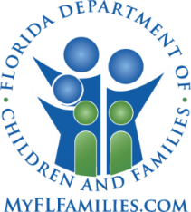
Clearinghouse
on Supervised Visitation
Phone Conference Agenda
August 15, 2018
12PM/11CT
Discussion

Welcome and Announcements
- Reminder to enter Access and Visitation Data
- Check the listings on the website to ensure your program information is up to date and correct. If you need to add/change anything: lbradley2@fsu.edu
- This is a reminder to get started on your program narratives. They are all due by the end of September, so please submit yours ASAP.
- Update from the Aug. 6 Trauma Informed Systems in Florida meeting
http://www.floridatrauma.org/TraumaShowcase.pdf

Questions from Directors

Training and Building Protective Factors and Resilience

When things go right!

Seligman, M.E.P., Steen, T.A., Park, N., & Peterson, C. (2005). Positive psychology progress: Empirical validation of interventions. American Psychologist, July-August, 410-421.

Gable, S.L., Gonzaga, G.C., & Strachman, A. (2006). Will you be there for me when things go right? Supportive responses to positive event disclosures. Journal of Personality and Social Psychology, 91(5), 904-917.

Three Little Things That Went Right Today!
1._____________________________
2._____________________________
3._____________________________
Examples: Everyone got to school on time. Jasmine remembered to turn in her paper. Chris helped a classmate who fell down. Mom read to Josie. Mark made his bed. Rose took out the trash. Dad put gas in his car for the week.

Ideas for Fundraising
Check out these fundraising ideas the Clearinghouse has curated:
Book Drive
Books are essential at SV programs. Ask businesses to allow you to leave a box for book donations. You can also ask your local library for help in organizing the event, for general resources, and even donations. 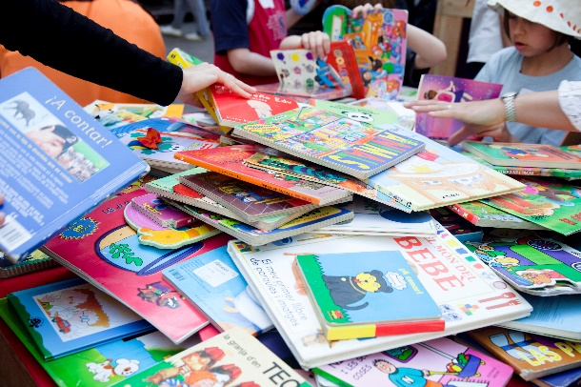

Outrageous Bet for Charity
You can come up with outrageous, fun, and safe bets for people to do to show support for your cause. You charge participants an entry fee into all the fun, or they can gain sponsors to complete the bets. The more sponsorships someone gets, the better the
game! Sponsors can send in a bet with their donations so that they can be involved. Examples of bets may include,
dying their hair a cool color, dressing up in strange costumes, post funny stories on social media. If you want to raise more

money and awareness about your event, post it on social media. The more accessible it is the more likely people will participate.
Murder Mystery Dinner
This event might take a lot more planning and time than other events. A price can be charged to participate in the party. There can also be various activities or foods sold throughout the party, to raise more money. It is essential to know your audience, so you can plan the party accordingly, and make adjustments as necessary. After deciding on your audience, you can choose a theme for the party, such as the wild west, an old manor, costume ball, etc. Character assignment is a crucial aspect of the game. Hosts often decide who will be who by assigning characters to guests by personality, random assignment, etc. The guests should have a name and a description of the character. The game will occur in rounds. The first round is where the guests mingle and reveal their characters through their clue cards. The clue cards should contain clues to reveal other players, information to conceal about respective characters, and motives. The secrets in this round will come out as the game continues. Then the second round starts, and the next batch of clue cards are handed out. These clue cards will help move the investigation along by providing new information about players and revealing forensic evidence. The players will then investigate, and try to find out who the murderer is before they escape or time runs out. The host can identify the victim in the second round, or the guests can know about the victim before the party. The victim does not have to be a guest at the party. However, if they are they can play the role of their ghost and reenact scenes that lead up for their death or speculations from other players. The third round is the accusation round where guests will reveal their guess for who the murderer is. Then the host will pass out the solution cards to each player; it will reveal their solution and involvement in the murder. The murderer will reveal themselves at the end of the game. The host can choose to host an award ceremony; this can be used to announce how much money was raised and possibly thank sponsors and involved parties.
For further questions of specifications go to: https://www.mymysteryparty.com/how-to-host-a-murder-mystery-party/

Board Game Tournament
A board game tournament is an excellent was to raise money, it’s generally pretty cheap, kid-friendly, and easy to monitor. There are various ways to host board game tournaments. For example, you could have various groups playing the same game and as groups win the climb up the bracket and battle other teams until there is a winner. The other way is to play various games going on at the same time with winners for each respective game. An entry fee can be charged to enter the tournament. You could even charge a fee for losing, for each game played, for the refreshments, ask for donations. Prizes for winning can include bragging rights, donated items, inexpensive trophies, etc. You can also ask that groups fundraise a certain amount for entry into the tournament. 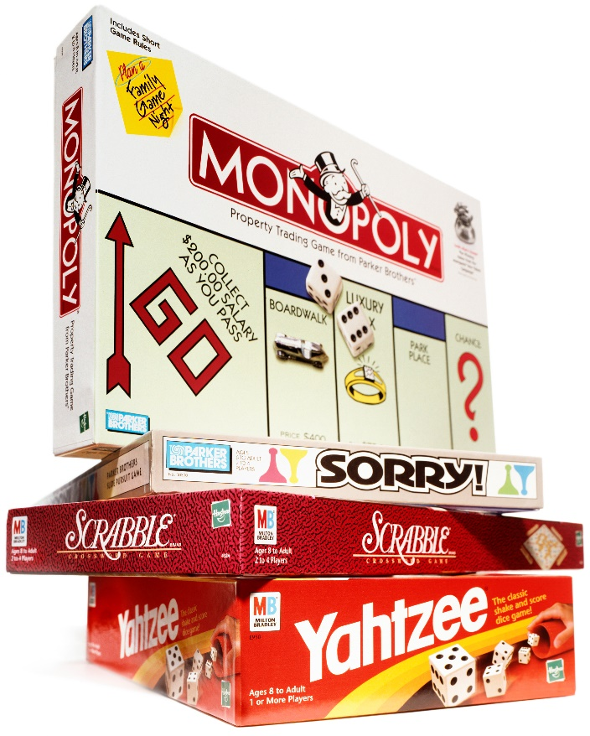

Applebee’s Flapjack Fundraiser
Applebee’s Neighborhood Bar and Grill will host a pancake breakfast fundraiser for non-profits and charities during their non-operating hours. To plan this event visit www.flapjackfunds.com and reserve a date. Once the request is received, and Applebee’s manager will contact you to
confirm the event and answer any questions.
Applebee’s will provide:
- Venue
- Kitchen and management staff
- Plates, utensils, and glasses
- Food/ingredients and prepare food
- Tickets and flyers for groups to copy and advertise
The organization is responsible for:
- Advertising the event
- Providing the wait staff (Greeting, seating, serving, and clean up)
- Printing and selling the tickets for the event. (Applebee’s takes $3 dollars per person to cover the cost of food, so consider that when pricing the tickets. Recommended costs of tickets are $11-$13)
Giving Tree
The giving tree is an easy and cheap way to raise money or get donations. You place a small tree in a local location where it will get a lot of participation. There should be a description of what the giving tree is for, what type of donations are needed and any other pertinent information. Put a fun and personalized spin to it by attaching information to the tree, such as monetary values, gift requests, personal stories. For example, Sophie would like a Barbie backpack, you have selected a donation amount of $25, Jess is a victim of … and this is her story. It is essential to have the giving tree in a location where it can be monitored whenever it is out. Also with monetary donations, it is ok to have a donation request on the tree, but the money should be donated through a secure platform, which maybe a person, an account, or a website. The personal information of someone should never be used without their permission, and you should only release someone’s first name when speaking of them. If someone wants their story shared, but not their name, then feel free to accommodate to his or her request, and make a pseudo name or state that information in his or her story.
Positive Affirmations Donations
Everyone loves positive affirmations, plus it’s an easy and fun way to spread happiness and raise money! Set up a way for people to sign up and pay to receive texts, calls, or emails to receive positive affirmations. People will pay to get words of affirmation sent to them. Prices can vary per day, per text, or come in package deals. Designated individuals will be in charge of sending the affirmations out. It comes at no cost to the hosting party, and will brighten someone’s day!

Awareness Bracelets
Make or order bracelets to sell and raise awareness for your organization. You can generally charge more for homemade bracelets or bracelets that are better quality. General donations can also be accepted when selling the bracelets. There are also various companies that can mass produce plastic and silicone bracelets for cheap. Characteristics to help you figure out what type of bracelet you want include:
- What quality do you want the bracelets to be?
- How many do you want to sell?
- Whether you want words or a message on the bracelet?
- How much do you want to sell them for?

Amazon Smile
Amazon has a program called AmazonSmile where people can link their Amazon accounts to charitable organizations. For every eligible AmazonSmile purchase, they will donate 0.5% of the price to the organization. All the same products available on Amazon will be available on AmazonSmile. Visit org.amazon.com for more information. To register an organization, follow the steps below:
- Use the name or EIN of the organization to search. Then confirm it is the correct organization.
- Create an organization administrator and accept the AmazonSmile Participation Agreement on behalf of your organization. An administrator will be the representative of your organization and will receive information regarding the account and promotions.
- Verify the organization email
- Submit banking information
- Upload a copy of a voided check or bank statement

You can find more fundraiser ideas here! https://www.causevox.com/fundraising-ideas/

