**Clearinghouse on Supervised Visitation  
Technical Assistance Conference Call**

C:\Users\amaselli\AppData\Local\Microsoft\Windows\Temporary Internet Files\Content.IE5\WJQW56IR\MC900434631[1].wmf

**September 2014 Phone Conference**

**Wednesday, September 17th at 12ET/11CT.**

**Agenda**

1. **Announcements. Children’s Justice Center receives grant to replicate the SIP project.**

***http://familyvio.csw.fsu.edu/low-income-families-using-supervised-visitation-to-improve-family-stability/?preview=true&preview\_id=3581&preview\_nonce=0850b05da0***

1. **Training/ Questions:**
   1. **Traditional vs non-traditional clients. Dependency cases, termination of parental rights.**
   2. **Co-sleeping reminders for parents (top reasons for accidental child deaths) and research.**
   3. **Trauma-Informed Care: Stress/wellness Issues for parents and staff (attach PP and worksheets)**
   4. **Smart Phone App for Parenting**
2. **Cases of the Month; Questions from Directors: working with magistrates.**
3. **Training Topic: Goal setting with clients. SMART goals. Skill building. We’ve developed worksheets to help them get organized! Family- Centered practice.**

Dangers of Co-Sleeping

Co-sleeping is a controversial topic because many parents want to sleep with their infant in their bed with them for the close proximity, particularly for the ability to breastfeed throughout the night, but co-sleeping can be very dangerous and should be advised against. Research reveals the risks involved.

The Dangers of Co-Sleeping:

Co-sleeping is dangerous for several reasons:

* Involves risk of rolling onto infant
* Increases risk of baby suffocating from being face-down in the bed
* Creates the potential for an infant to get his/her head trapped in the bed frame or headboard and cause strangulation
* Creates the potential for an infant to get wedged into a small space such as in between the bed and the wall leading to suffocation
* Increases risk of suffocating in loose blankets, pillows, sheets, etc.
* Dramatically increases the risk of sudden infant death syndrome (SIDS), especially for infants less than 3 months old

According to the U.S. Consumer Product Safety Commission (CPSC) from January 1990 to December 1997, there were approximately 500 infant deaths that were directly related to co-sleeping, and over three-quarters of these deaths occurred in infants who were less than 3 months old.

Factors for Increased Risk:

Clearly, co-sleeping can greatly increase the risk of harm to an infant in any circumstance, but there are several factors that further increase this risk that parents should be aware of, including:

* If either parent smokes due to the increased risk of SIDS
* If either parent has consumed any alcohol or drugs (regardless of if they are prescription drugs prescribed to that parent)
* Other children also co-sleeping with the infant and parents, especially toddlers because they are less aware of the infant
* Obesity of a parent, due to increased risk of rolling onto an infant and suffocating him/her

Further Negative Effects on the Family:

Co-sleeping is dangerous for these very serious reasons, but it can also be detrimental to the family in other ways. Co-sleeping can prevent parents from sleeping well, which can affect their work performance and parenting abilities. Co-sleeping can also make a child dependent on sleeping with his or her parent, which can make nap time or putting the child down before his/her parents want to go to sleep much more challenging. Although these considerations may be less dramatic than the dangers of SIDS and suffocation created by co-sleeping, these are further reasons that parents should be encouraged not to co-sleep with their infant.

Room-Sharing:

The CSPC and the American Academy of Pediatrics (AAP) both recommend against co-sleeping. Instead, parents should be encouraged to participate in room-sharing because it provides a similar proximity between the parents and infant that is often desired by co-sleeping families. Room-sharing still allows a mother to more easily breastfeed her infant throughout the night as well. Room-sharing involves the use of a crib or bassinet in the parents’ bedroom to provide proximity to the infant, and the crib can even be placed very close to the parents’ bed. This still prevents the risk mentioned previously of rolling over onto the infant. Well-fitted sheets should be utilized in the crib, and loose blankets and pillows should still be avoided to prevent the other risks mentioned earlier that increase the risk of a child suffocating.

Although co-sleeping is still controversial and many parents desire to do so, due to the extremely serious risk of this habit parents should be discouraged from participating in co-sleeping. Parents should also be made fully aware of these risks so that they might understand the dangers of co-sleeping. This is particularly true if the infant is less than 3 months old. If parents are adamant about maintaining a close proximity to their infant throughout the night room-sharing should be strongly encouraged as a safe, effective alternative that provides them with this close distance. They should still be made aware of the risks of co-sleeping though and the tips mentioned above about room-sharing, including ensuring that there are tight-fitting sheets within the crib to reduce as much risk for the infant as possible. This alternative can dramatically reduce the serious dangerous involved in co-sleeping with an infant.

Co-sleeping Resources: [http://kidshealth.org/parent/general/sleep/cosleeping.html](http://kidshealth.org/parent/general/sleep/cosleeping.html" \t "_blank)

<http://commonhealth.wbur.org/2013/11/is-it-time-to-rethink-co-sleeping>

<http://www.marchofdimes.org/baby/co-sleeping.aspx>

<http://www.webmd.com/parenting/baby/features/cosleeping-baby>

<http://www.choc.org/publications/index.cfm?id=P00303&aid=241>

**Co-Parenting App**

**2houses**

*This app is recommended* *for parents who have the willingness to facilitate a positive and collaborative co-parenting relationship that is focused on the children and need the structure and organization of an app to assist them.*

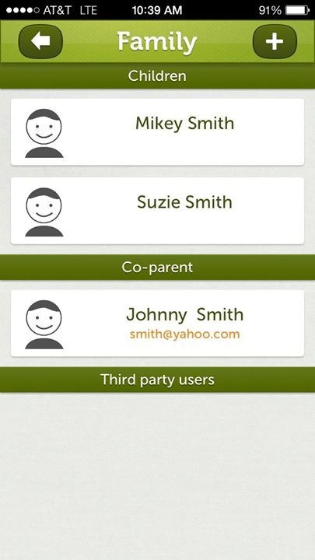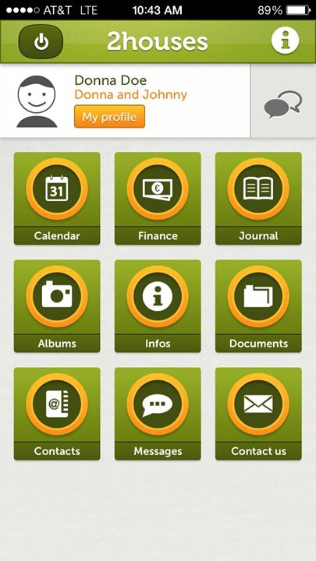

**Features:**

**Joint Calendar**

* This calendar can be edited by both parents. Has a Parenting Schedule feature that can be edited by both users. Allows for management of custody schedule. Events can be recurring. Allows you to request to make a change to a schedule. By utilizing both the phone app and the website, co-parents can view the calendar in many different formats depending on which they like the most.

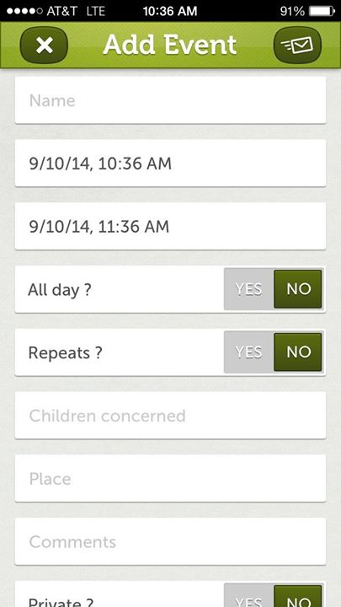

**Info Bank**

* Phone Numbers, medical information, and other important details can be listed and shared. Parents input this information on the 2houses website by logging into their account.
* Small details such as your children’s clothing size, last vaccines, phone number of the math teacher, relative’s phone numbers. These are details that when parents were together, maybe one parent knew more than the other. This part of the app allows for more independence because the parents have access to the same information without having to contact each other for it.
* Also great in the moment of an emergency. Any information that a parent may want to share on here about their children can be put here.

*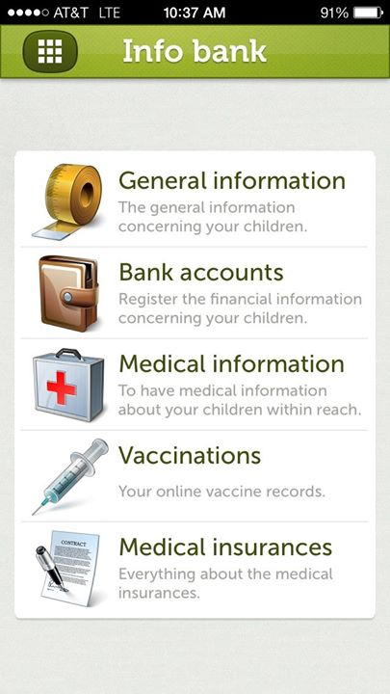*

**Finances**

* Each parent can add expenses with detailed information about cost, how much each parent is paying, the purpose of the expense, and what the expense was. There is also a section for payments where there is record of how much each parent has already paid and for what they paid for.
* Excellent tool because finances are one of the biggest adjustment parents have to make after divorce. Agreeing on how much each parent will pay, and making sure that each parent notifies the other when they are going to make a purchase is important. This app facilitates the agreement that the parents have made about finances.



**Journal**

* Allows posts, pictures, quotes, and videos to be posted
* Can reassure parent that the kids are in a safe place and are having fun with other parent
* Allows for quick sharing and the photos and posts all stay in the app so the user can look back
* Priceless moments with the children can be shared with both parents

****

**Messages**

* Allows for private messages to be posted and responded to back and forth
* Communication that is quick, easy.
* Important feature because it gives parents another option for the way they want to communicate.. Does not require direct contact, such as talking on the phone.

**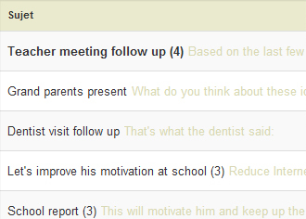**

**Pros:**

* **Facilitates communication between co-parents**
* **Helps with organization of schedule, expenses, and important information.**
* **Quick and easy to use- User Friendly**
* **Free**
* **Focuses on the children and their needs**

**Cons: Only available for the Iphone, not android**

* **If one parent is not willing to communicate maturely, this app may not be the most effective way to get help with co-parenting.**
* **Not effective for situations in which abuse/violence are present.**

**Traditional and Non-Traditional Clients**

Social service and supervised visitation providers work with a broad range of clients. Clients range from traditional to non-traditional, based on how they present themselves and how they interact with the provider. Here is some information about traditional and non-traditional clients, as well as tips for social service providers to remember when working with any client. Remember, all clients deserve to be treated with dignity and respect, and many have been victims of trauma at many points in their lives.

***The Traditional Client***

The traditional client is a client that many social service providers are familiar with. These clients tend to be compliant and easy to work with. Some characteristics of traditional clients may include:

* Compliance/Rule Following
* Eager to follow staff directions
* Appreciative
* Calm
* Respectful
* Predictable
* Communicative
* Open
* Stable in affect

***The Non-Traditional Client***

The non-traditional client is also a type of client many social service providers will encounter, specifically social services providers who work with clients who are not *voluntary* clients and those who have suffered trauma. These can include parents in the Dependency system, those who may lose their parental rights, and those who have experienced difficulties in litigation, the criminal system, and other arenas. Some characteristics of non-traditional clients may include:

* Unpredictable
* Noncompliant
* Push boundaries
* Angry
* Frustrated
* Erratic
* Resentful
* Difficult to read
* Closed off to communication
* Hostile

***Some Things to Remember***

Understanding traditional and non-traditional clients is important for social service providers to best serve their clients. However, it’s also important for social service providers to remember the following:

* Just like everyone else, clients can and do change. A client may be traditional when he or she starts receiving services but then become more non-traditional as his or her situation changes, or in response to new trauma, or for any other reason. The opposite is also possible. A client may be very non-traditional, but become more traditional and easier to work with over time.
* A client may be compliant one day and noncompliant the next. Social service providers should remember not to expect consistency from clients.
* Client demeanor is often a result of client experiences and history. Remember that many clients have histories of trauma, victimization, and abuse. Clients can be afraid, frustrated, and angry for many reasons, and providers must learn to provide services in a manner that anticipates and responds to these emotions.
* For the safety of the social service provider, as well as the clients themselves, it’s important for social service providers to not assume a client will ever act in a certain, expected way.

***Tips for Social Service Providers***

* Treat all clients with respect and dignity. Try to understand the client’s motive and intentions. Clients may be more receptive when they are better understood.
* Don’t count on clients remaining the same in a given situation.
* Always remain vigilant about safety issues. Just because a client has been quiet and calm in the past doesn’t mean he or she won’t become erratic in the future. Social service providers should not become complacent on safety issues simply because a client has been compliant in the past.
* If a client makes a dramatic shift, social service providers should talk with the client to try and understand why this shift occurred. This knowledge can help the social service provider better work with, understand, and guide the client.
* Remember your safety and crisis intervention training with *every* client.







