Role-Playing Emotions with Children
As children grow, it is very important that they learn to understand not only their own emotions but the emotions of others as well. These activities help children learn to identify emotions in themselves and others. Understanding emotions plays an important role in Protective Factor 6: Social & Emotional Competence of Children.

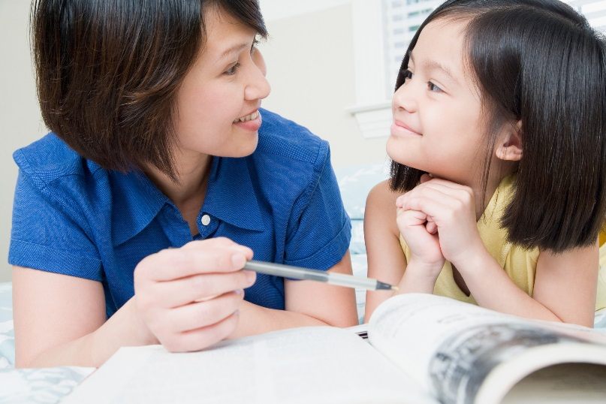
- Go in front of a mirror and have your child practice the faces appropriate for when he or she:
- Has a bad dream
- Goes to a friend’s birthday party
- Has a toy taken away
- Is missing someone (a friend, relatives, parents)
This activity allows your child to understand the expression he or she makes when feeling certain emotions and also how to recognize those emotions in others.
- Cut out four round pieces of paper and draw a different emotion on each piece, such as: a smiley face for feeling happy, a sad face for feeling sad, etc. Take a few minutes each day to ask your child to pick one up to tell you how he or she is feeling.
Doing this with children can help them easily and quickly decide which emotion fits their mood best and what that emotion looks like. Parents can also use this activity to show their children how they’re feeling at that moment and then ask their child, “When I have this face, how am I feeling?”
- Gather magazines and cut out photos of people expressing different emotions, such as excited, scared, happy, sad, etc. Ask your child to sort the photos into separate categories according to the different emotions.
This activity helps your child identify emotions in others, which can aid in the development of strong empathy skills. Have your child compete to sort the pictures faster and faster to encourage a strong concept of emotions.

